WHITFIELD & CRANE LLP

REGULATORY FREEZE REQUEST
MONEY LAUNDERING WHISTLEBLOWER

FINANCIAL TRANSACTION FORENSICS / CASE RECORD
TO: REGULATORY BODY | CASE NUMBER
Financial Conduct Authority (FCA) | #WC-2026-FX7717
FROM | SUBJECT
Whitfield & Crane LLP | Whistleblower Report & Freeze Request
TARGET INSTITUTION | VIOLATION TYPE
Wise Payments Limited | AML/KYC Failure & Money Laundering

01. SUMMARY OF REPORT
We have secured technical forensic evidence demonstrating that the regulated entity, Wise Payments Limited, is currently facilitating the processing of highly laundered criminal proceeds.

02. MONEY LAUNDERING FACTS & COMPLIANCE FAILURES

Funds tracing reveals the illicit assets underwent 167 anomalous transfers, routing through fictitious trade accounts and crypto mixers. The funds were ultimately received by the following account on the Wise platform:
Account Name: Toby A Blackburn | Account Ending: #8842
The high-frequency, large-volume anomalous deposits into this account constitute a direct violation of standard KYC/AML regulations, indicating a failure of oversight by the Wise platform.

03. REQUEST FOR REGULATORY INTERVENTION
Pursuant to the UK Proceeds of Crime Act 2002 (POCA), we urgently request the FCA to:
• Issue a mandatory freeze order against the Wise platform account ending in #8842.
• Launch an investigation into the compliance failures of the Wise platform within this specific money laundering chain.

Counsel Signature:  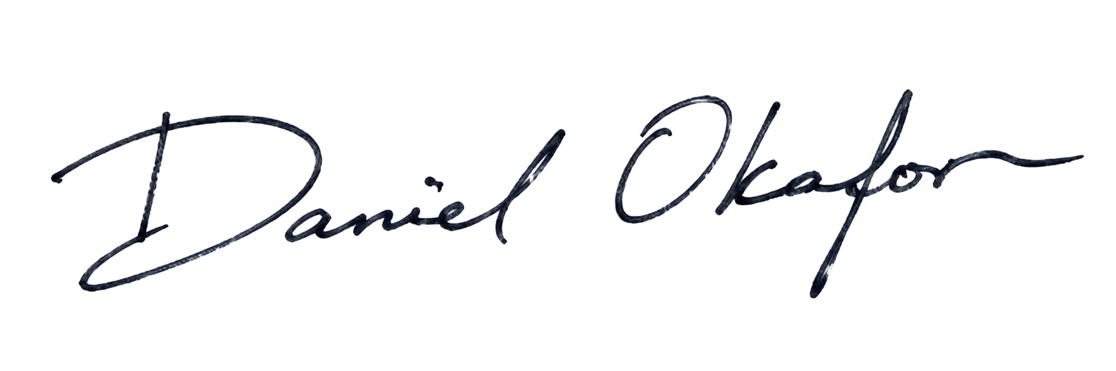 | 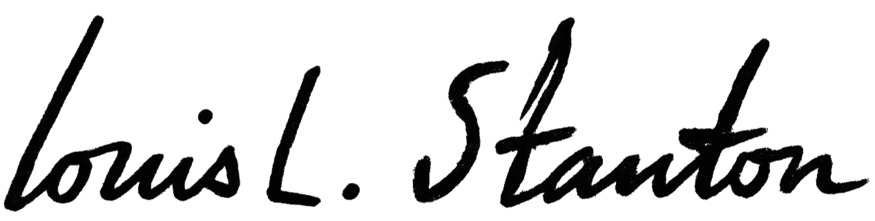  Judge Signature:
Name: | Name:
当天日期 | 当天日期

